**WIA1002/WIB1002/WXES1117 Data Structures**

**Tutorial 5: Stack**

**Question 1:**

The stack method that returns an element from the stack without removing it is ____________.

* 1. pop
  2. push
  3. peek
  4. spy

**Question 2:**

We have three stacks, s1, s2 and s3, that can contain data of type String. Here are their initial contents:

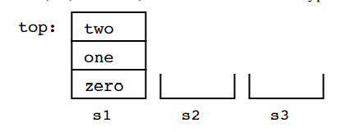

As you can see, initially s2 and s3 are empty. Here is a sequence of operations on the three stacks:

s2.push(s1.pop());

s3.push(s1.pop());

s1.pop();

s1.push(s2.pop());

s2.push(s3.pop());

s2.push(s1.pop());

Draw the contents of the three stacks after the operations are complete.

**Question 3:**

Over time, the elements 1, 2, and 3 are pushed onto a stack **in that order**. For each of the following, indicate (yes or no) whether the sequence could be created by popping operations. If yes, list the sequence of push() and pop() operations that produces the sequence.

(a) 1-2-3 (b) 2-3-1 (c) 3-2-1 (d) 1-3-2

**Question 4:**

Convert the following infix expressions to postfix:

1. a + b * c
2. a * b – c/d
3. a + (b*c + d)/e

**Question 5:**

Write the following expressions in infix form:

1. a b + c *
2. a b c + *